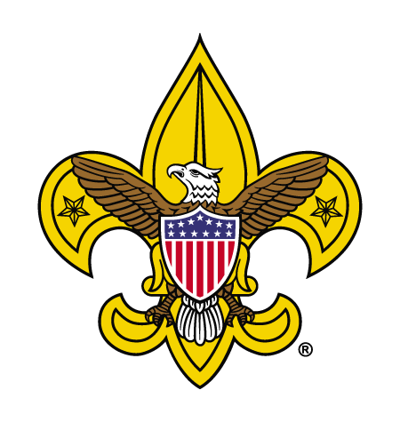**SCOUTS BSA TROOP**

**0000**

**CHARTERED ORGANIZATION NAME- CITY, OHIO**



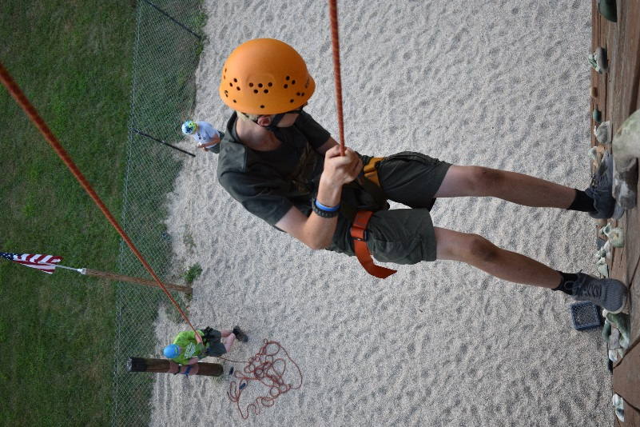

**Annual Membership Dues**

**$50**

What’s Included:

$34- BSA Membership Fee/Insurance

$16- Awards (Merit Badges & Ranks)

**One-Time Costs**

$30-$45 Uniform Shirt

$28-$40 Uniform Bottoms

$12 Uniform Patches

$13 Uniform Belt

$15 Uniform Hat

$8 Uniform Socks

$18- Scouts BSA Handbook