**SCOUTS BSA**

**TROOP 0000**

**CITY, OH**

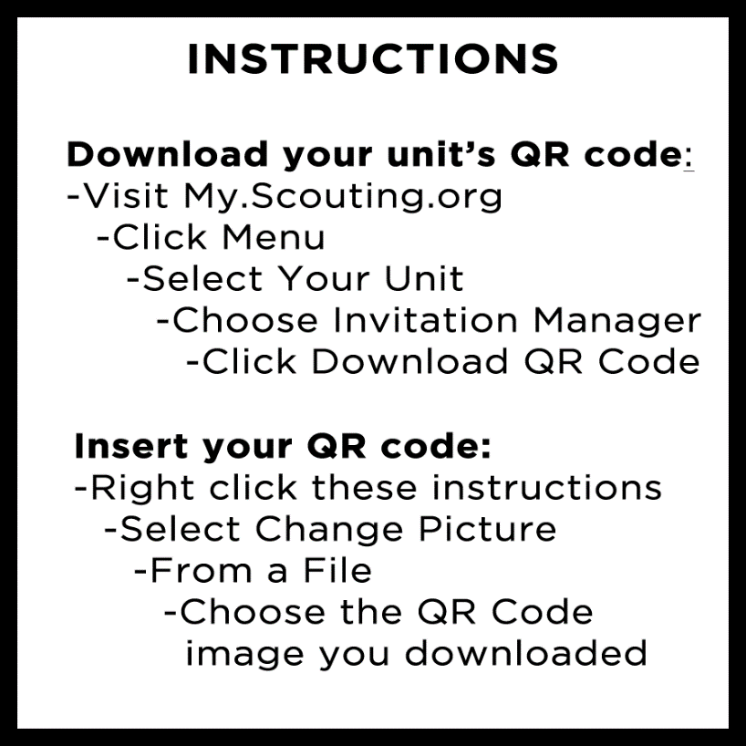

**SCAN BELOW, CREATE AN ACCOUNT,**

**COMPLETE YOUR APPLICATION, AND PAY ONLINE**